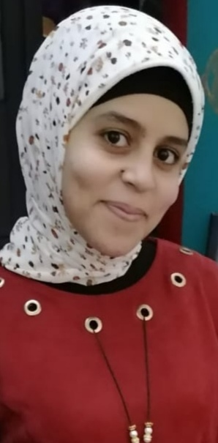
Address:
Al Mashaa village, Alghanayem Center.

Phone:
01068123387
Email:
Shaimaa_rateb@nursing. aun.edu.eg

Languages
- Arabic
- English

Skill Highlights

- Problem solving.
- Time management
- Work under stress.
- Cooperation with others in the work.
- Good leader.

Education
Bachelor of Nursing: Demonstrator in psychiatric department.

Certifications
- Mechanical ventilator training (2017).
- First aids ( 2017).
- Elementary level course ( December 2020).
- IC3 GS5 Course (from September to October 2020).
- Publication of research in international journal( NOV2020).
- Crisis management (NOV2020).
- Quality standers in teaching (NOV2020).

